PRODUCT REQUEST FORM
PRODUCT NAME: | Sterile Chemotherapy (Chemo) Gloves
DESCRIPTION OF REQUEST:  - New Product  - Modification  - Product Extension  - Country addition  - Label Change  - Intended Use  -…Etc… | This initiative targets the critical and growing segment of hazardous drug (HD) compounding within the compounding pharmacy market.  Project Background  The enforcement of USP <800> has created a distinct and expanding market segment focused on operator and environmental safety during hazardous drug compounding. Within this framework, Sterile Chemotherapy Gloves are not merely an option but a required component of double-gloving protocols for HD handling. They are specifically tested against a suite of chemotherapy drugs for permeation resistance, offering a level of protection far beyond standard sterile nitrile gloves.  Our channel analysis confirms that HD compounding represents a significant portion (~20%) of pharmacy activities, with specialized consumables commanding premium pricing. Developing or sourcing a new glove model to meet these rigorous ASTM D6978 standards would be a complex, multi-year endeavor. Therefore, the strategic and expedient path is to distribute an established, Branded Chemo Glove that is already validated and trusted by the market. This approach:  - Provides immediate access to a compliant, high-margin niche with a clear regulatory driver.  - Mitigates the technical and regulatory risk associated with introducing a new product in this highly sensitive safety category.  - Completes our “Hazardous Drug Compounding Safety Suite”, allowing us to offer a coordinated solution alongside CSTDs (Closed System Transfer Devices) and Level 4 Chemo Gowns.  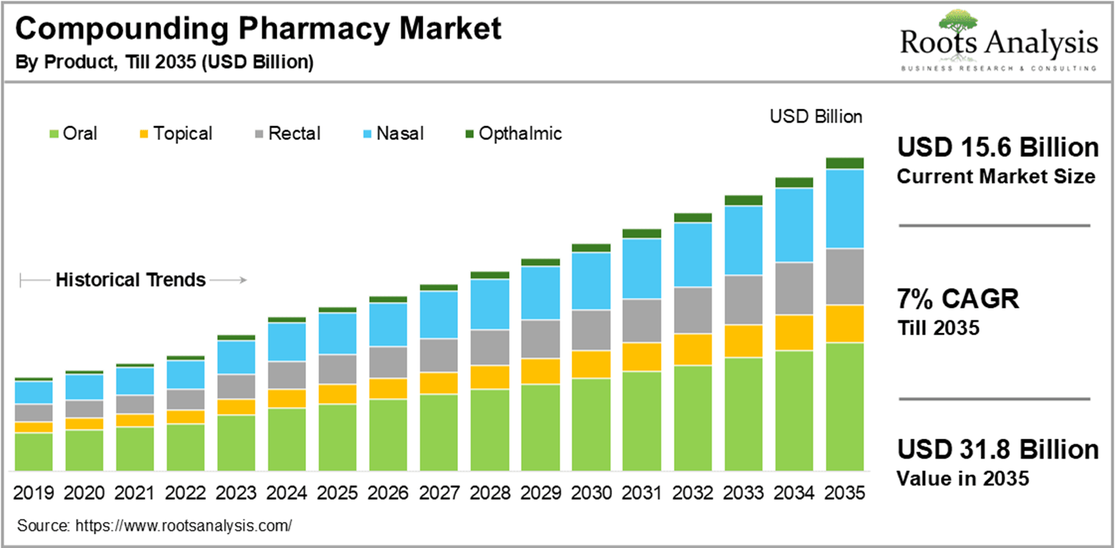
PURPOSE OF REQUEST: | ☐Complaint No. ☐Supplier ☒New market_______US_________  ☐Customer ___ ☐Internal _ ☐Other________________________  Add details:
ESTIMATED BENEFITS: | ☒ Financial Benefit:_Complete the product lines for the Compounding Pharmacy markets, Annual sales amount $ 150M (Mandatory For NPD request)  Estimate the potential increase in cash flows, revenues, or any other financial benefits  ☐ Cost Saving:__________  Decrease in the cogs, transportation or operation expenses, or any other cost-saving opportunities  ☐ Improved Operational Efficiencies:_________  Decrease in the Lead time, delivery time, MOQ, Inventory, or any other efficiency improvement  ☐ Non-Financial Benefits:_________  Quality Improvement; Enhanced customer satisfaction, product competition, Brand reputation, etc.  ☐ Other Benefits:__________
PRODUCT DESCRIPTION:  - Functional performance requirements  - Appearance  - Any unique points of differentiation against similar competitor product lines  . ..Etc… | Product Definition & Scope 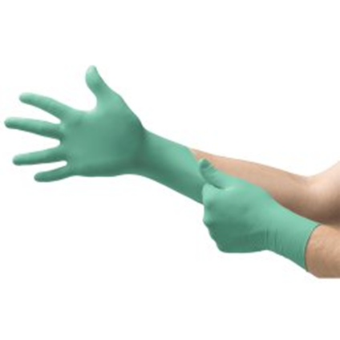  - Product: Sterile, powder-free nitrile chemotherapy examination gloves, certified to ASTM D6978 or equivalent standards for permeation resistance to specific hazardous drugs.  - Primary Use: As the outer glove in a double-gloving system for personnel compounding or handling hazardous drugs, in full compliance with USP <800> requirements for personnel protection.  - Partner Profile: A recognized manufacturer with specialized expertise in HD safety products, possessing comprehensive product validation data and a strong reputation within the oncology and compounding pharmacy sectors.  3. Agent Brand Proposal  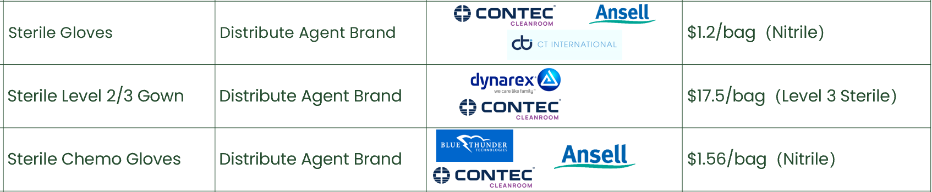
REQUEST TYPE | ☐LCR (Labelling Change Request)  Changes on the labels without changing the products  ☐SCR (Supplier Change Request)  Change applications initiated by Suppliers  ☐ECR (Engineering Change Request)  Existing products that SOLM is the legal manufacturer  Engineer changes that are not bringing new hazards/risks  ☐NPD (New Product Development)  Develop new innovative products that SOLM will be the legal manufacturer  Significant changes on existing products that may bring new hazards/risks or new intended use  Change products from outsourcing to SOLM to be the legal manufacturer  Development of VET/Component products  ☒SDP (SOLM Distributor Product)  New product introduction that SOLM will not be the legal manufacturer  No change on the product, no SOLM information on the labels  ☐SPP (SOLM Portfolio Product)  New product introduction that SOLM will not be the legal manufacturer  No change on the product, Add SOLM information on the labels  ☐Customized Product / Market  Purchased products that SOLM is not the legal manufacturer  Engineering change on products or new customized products requested by SOLM  New Market region requested by SOLM
TARGET MARKET: | ☒ US ☐ Canada ☐ EMEA ☐ UK ☐ Brazil ☐ Australia & New Zealand ☐ Other countries/regions, list:
TARGET USE: | ☒ Human Use  ☐ Animal Health | STERILE | ☒ YES  ☐ NO
VOLUME/SALES OPPORTUNITY: | Launch volume required: | Yr 1 estimate | Yr 2 estimate
CUSTOMER NOTIFICATION | Do we have any special quality agreement in place with customer which requires approval before implementing changes? ☐ YES ☒ NO  If Yes, please provide the customer's name and evidence.  Attach the customer confirmation GF-0083 at the end of the form.  Is notification to the customers needed after change project is closed? ☐ YES ☒ NO  Remark:  Example: change affect regulatory, performance, appearance, etc. Notification method.
LEGAL MANUFACTURER: | ☐ Sol-Millennium  ☒ Other: __________ | BRANDING | ☐ Sol-Millennium  ☐ Private Label
EXPECTED PRODUCT LAUNCH PERIOD: | ☒ < 1 year  ☐ 1-3 year  ☐ > 3 years | EXPECTED PRODUCT LIFE PERIOD: | 10 years
NAME AND DATE of REQUEST: | Alex Lu 2026/2/9
Product | COO | McKesson Uni Price | Target Uni Price | Target Gross Margin | Annual consumption in US | Solm采购量（10% ） | Est. Sale Revenue
Sterile Chemo Gloves | US | 1.97 | 1.30 | 40% | 1,200,000,000 | 120,000,000 | 156,000,000

